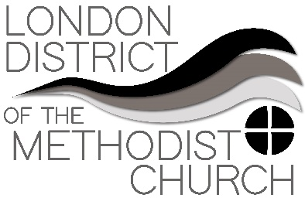
Sharing Best Practice – A Forum
Forum One - Funerals

People shared their experiences, which were often moving and reflected the challenging circumstances in which we offer care at this time. Just some of the examples of good practice offered were:

- Enable people who can't attend to feel a part of the service. For example, let the time of the service be known to the wider church family if appropriate, as well as friends and relations who can’t be there so that prayers can be said at the same time – make a service sheet available.
- People might find it helpful if there is the possibility of a memorial service to be conducted at a later date, so that proper tribute and goodbyes can be planned.
- Prayers from Methodist Church House were cited as being very good - check out the website www.methodist.org.uk
- Create a WhatsApp group to include friends and family and church members as funeral preparations are made
- The actual burial itself can be Zoomed to those who can’t be there or filmed and distributed later.
- Bear in mind the range of levels of competence and confidence that people have in using IT, and remember that some members of communities and congregations don’t use written material very much – so audio recordings might be a helpful way to include people.
- Proactive communication with funeral directors can help avoid mix ups and remembering that they too are facing challenges and need support.
- Don't struggle - find people to talk to, colleagues within or beyond your circuit and look for agencies that offer support, for yourself and to which you can signpost others. See list below:
​
The Methodist Church has provided some 'Prayers For The Dying'.
​
Church communities and ministers have always been gifted in responding to the needs of the dying and the bereaved. At the moment there can be a sense of being overwhelmed, especially if we tend to 'just get on with it ourselves'. We must, of course, look to each other for support but there are other agencies that also have resources and offer support in bereavement situations. You might want to use these charities for your own support or signpost other people to them. If you are feeling overwhelmed, please do talk to colleagues and lay leaders in your circuits.
​
- Cruse Bereavement Care
- The Good Grief Trust
- At A Loss
​
And for practical help following a death in hospital, look at the NHS Coronavirus pages:
https://www.nhs.uk/conditions/coronavirus-covid-19/bereavement-advice-and-support/

Don't forget to regularly look at the Methodist Church Website for updates and information.
https://www.methodist.org.uk

