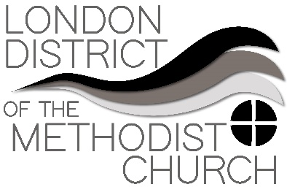
Sharing Best Practice – A Forum
Forum Five: Keeping whole and holy
Within this Zoom session we discussed the importance of entertainment during lockdown, and shared news of how we are each keeping ourselves and others entertained during lockdown.
​
- We discussed the importance of intentional play, activity in garden or walking and the need to maintain body care and mental awareness
- Keeping connection with colleagues is important, especially when supernumerary and feeling out of the loop
- Yielding to own creative side e.g. creating music. Some reported singing and dance classes continuing online – and book reading. It is also a good time to maybe learn or brush up on a language. Duolingo has proved a useful app to download which is warmly recommended.
- For some it has been a real opportunity to get to know the neighbours
- Sharing quizzes (Try using these two free apps Kahoot! or Psych! which work through normal zoom technology once downloaded). Where there are technical issues some have distributed printed copies.
- It may be significant to mark endings/beginnings under lockdown.
- Worries were expressed about coming out of lockdown – and how for some this is not going to be a joyous process. Maybe this could be a subject for a later zoom best practice.
- Praise was given to the Methodist Prayer Handbook.

